|  |  |  |  |  |
| --- | --- | --- | --- | --- |
| Name: | ___________________________________________________ | | | Date: *___________* |
|  | **Year 11 Applications**  **Test 1, 2015**  **Topics – Substitution & Formulas, Percentages & Rates and Simple & Compound Interest** | | | 55  = % |
| **Total Time:** | ***60*** *minutes* | SOLUTIONS | | |
| **Total Reading:** | *5**minutes* |
| **Total Working:** | *55**minutes* |
| **Weighting:** | *10% of the semester.* |
| **Equipment:** | *SCSA Formula Sheet; ½ page notes (A4 one side), CAS calculator; Scientific Calculator* | | | |
|  | | | | |
| **SECTION 1: CALCULATOR FREE** | | | | |
| **Time:** | ***22*** *minutes* | **Marks for Section 1:** | *20* | |
| **Reading:** | *2**minutes* | **Equipment Allowed:** | *Nil* | |
| **Working:** | *20**minutes* |  |  | |

|  |  |  |  |
| --- | --- | --- | --- |
| **1.** | **[4 marks: 1 mark each]** | | |
|  | Find the value of each of the following expressions given that *x* = 4 and *y* = 3. | | |
| **a)** | 2*x*2 | **b)** | (*x* – 2)3 |
|  | 32 ✓ |  | 8 ✓ |
| **c)** | 6*x* – 2*y* | **d)** | (*x* + *y*)2 |
|  | 18 ✓ |  | 49 ✓ |

|  |  |  |  |
| --- | --- | --- | --- |
| **2.** | **[3 marks: 1 mark each]** | | |
|  | Express the following percentages as decimals. | | |
| **a)** | 8.5% | **b)** | 2% |
|  | 0.085 ✓ |  | 0.02 ✓ |
| **c)** | 115% |  |  |
|  | 1.15 ✓ |  |  |

|  |  |  |  |
| --- | --- | --- | --- |
| **3.** | **[4 marks: 1 mark each]** | | |
|  | Convert the following to percentages. | | |
| **a)** | 0.25 | **b)** | ¾ |
|  | 25% ✓ |  | 75% ✓ |
| **c)** | 2.4 | **d)** | 1½ |
|  | 240 % ✓ |  | 150% ✓ |

|  |  |  |  |  |
| --- | --- | --- | --- | --- |
| **4.** | **[3 marks: 1 mark each]** | | | |
|  | Expand and simplify the following expressions. | | | |
| **a)** | 4(*x* ‒ 2) | **b)** | ‒2(*x* ‒ 3) | |
|  | 4*x* – 8 ✓ |  | −2*x* + 6 ✓ | |
| **c)** | 5*x*(*x* + 4) |  |  |  |
|  | 5*x*2 + 20 ✓ |  |  |  |

|  |  |  |  |  |  |
| --- | --- | --- | --- | --- | --- |
| **5.** | **[6 marks: 1, 1, 2, 2]** | | | | |
|  | Solve the following equations. | | | | |
| **a)** | 4*x* + 1 = 9 | | **b)** | *x*2 = 25 | |
|  |  | 4*x* = 8  *x* = 2 ✓ |  |  | *x* = √25  = ± 5 ✓ |
| **c)** |  | | **d)** | 2(*x* + 4) = 16 | |
|  | 2*x* + 5 = 21 ✓  2*x* = 16  *x* = 8 ✓ | |  | 2*x* + 8 = 16 ✓  2*x* = 8  *x* = 4 ✓ | |

**~ END OF TEST SECTION 1 ~**

|  |  |  |  |  |
| --- | --- | --- | --- | --- |
| Name: | ___________________________________________________ | | | Date: *___________* |
| **SECTION 2: CALCULATOR ASSUMED** | | | | |
| **Time:** | ***38*** *minutes* | **Marks for Section 2:** | *35* | |
| **Reading:** | *3 minutes* | **Equipment Allowed:** | *½ page notes (A4 one side),*  *CAS calculator* | |
| **Working:** | *35**minutes* |  |  | |

|  |  |
| --- | --- |
| **6.** | **[3 marks: 1, 2]** |
|  | Courtney invests $25 000 at 2.65% p.a simple interest. Calculate the following. |
| **a)** | How much interest would she receive if she invested it for 12 months? |
|  | I = PRT  = 25000 × 0.0265 × 1  = $662.50 ✓ |
| **b)** | How long would it take for her to have $30 000 (including her original $25 000 investment)? |
|  | 30000 – 25000 = 5000  5000 = 25000 × 0.0265 × T ✓ ∴ 7.5 years ✓  5000 = 662.50 × T  T = 5000 ÷ 662.50  = 7.54716981.. |

|  |  |
| --- | --- |
| **7.** | **[3 marks: 1, 2]** |
|  | Answer the following in the spaces provided. |
| **a)** | Dayna bought a house for $345 000 and sold it 5 years later for $450 000. What was her percentage profit? |
|  | Profit = 450 000 – 345 000 105 000 ÷ 345 000 × 100 = 30.43% (2 dp)  = 105 000 |
| **b)** | Daniel invested $5000 in a Commonwealth Bank term investment account, where the interest rate of 5.75% p.a. is compounded monthly. If Daniel invested this money for 5 years, how much interest would he have made? |
|  | ✓  Interest earned = 6660.88 – 5000 = $1660.88 ✓ |

|  |  |  |  |
| --- | --- | --- | --- |
| **8.** | **[2 marks: 1 mark each]** | | |
|  | A department store increases their prices to remain in line with inflation. If the rate of inflation is 2.8%, calculate the new prices of the following: | | |
| **a)** | A Wii U console with Mario Kart originally $395 | **b)** | A Dragon Quest IX DS Game $49.95 |
|  | 1.028 × $395 = $406.06 ✓ |  | 1.028 × $49.95 = $51.35 ✓ |

|  |  |
| --- | --- |
| **9.** | **[5 marks: 2, 3]** |
|  | Calculate the best buys for the following questions. |
| **a)** | Lemonade is sold in the following packaging 2L for $2.90 or 1.25L for $1.95. |
|  | 2L = $2.90 1.25L = $1.95  1L = $1.45 ✓ 1L = $1.56 ✓  ∴ Best Buy |
| **b)** | Shanaya wants to buy some Krispy Kreme donuts. They have 2 deals going. Which is the better value for money?  **Deal one : $23.50 Deal two: $17.95**  This dozen box features: This box features: * 3 Frosty the Snowman doughnuts * 12 original signature glazed donut  * 3 Christmas Sprinkles doughnuts normally $1.95 each * 3 Christmas Tree doughnuts * 3 Snowflake doughnuts  Valued at $28.00 |
|  | $28.00 − $23.50 = $4.50 12 × $1.95= $23.40 $23.40 − $17.95 = $5.45  4.50 ÷ 28.00 × 100 = 16.07% ✓ 5.45 ÷ 23.40 × 100 = 23.3% ✓    ∴ Better Buy as higher percentage savings ✓ |

|  |  |  |  |  |
| --- | --- | --- | --- | --- |
| **10.** | | **[6 marks: 1, 1, 2, 2 ]** | | |
|  | | If *m* = 4 , *n* = ‒ 3 and *p* = 2.95, determine: | | |
| **a)** | 2*mn* ‒ *p* | | **b)** | 3*m*2 + 2*np* |
|  | 2 × 4 × -3 – 2.95 = −24 – 2.95  = −26.95 ✓ | |  | 3 × 42 + 2 × (−3) × 2.95 = 30.3 ✓ |
| **c)** |  | | **d)** | *p*2 + 4*n*(*m* ‒ *p*) |
|  | ✓ ✓ | |  | 2.952 + 4 × (−3) × ( 4 – 2.95) = −3.8975  ✓ ✓ |

|  |  |
| --- | --- |
| **11.** | **[5 marks: 1, 1, 1, 2]** |
|  | Answer the following questions using the exchange rate table below. |

Rates Converter for 1.00 Australian Dollar

Dec 17, 2014 00:34 UTC

| **Australian Dollar** | **1.00 AUD** | **inv. 1.00 AUD** |
| --- | --- | --- |
| Euro | [0.657358](http://www.x-rates.com/graph/?from=AUD&to=EUR) | [1.521242](http://www.x-rates.com/graph/?from=EUR&to=AUD) |
| US Dollar | [0.821875](http://www.x-rates.com/graph/?from=AUD&to=USD) | [1.216729](http://www.x-rates.com/graph/?from=USD&to=AUD) |
| British Pound | [0.522277](http://www.x-rates.com/graph/?from=AUD&to=GBP) | [1.914694](http://www.x-rates.com/graph/?from=GBP&to=AUD) |
| Indian Rupee | [52.306420](http://www.x-rates.com/graph/?from=AUD&to=INR) | [0.019118](http://www.x-rates.com/graph/?from=INR&to=AUD) |
| Canadian Dollar | [0.956119](http://www.x-rates.com/graph/?from=AUD&to=CAD) | [1.045895](http://www.x-rates.com/graph/?from=CAD&to=AUD) |
| New Zealand Dollar | [1.056231](http://www.x-rates.com/graph/?from=AUD&to=NZD) | [0.946763](http://www.x-rates.com/graph/?from=NZD&to=AUD) |

|  |  |  |  |
| --- | --- | --- | --- |
| **a)** | What is $1 Australian dollar worth in US Dollars? | **b)** | What is $1 New Zealand Dollar worth in Aust $? |
|  | 0.821875 ✓ |  | 0.946763 ✓ |
| **c)** | Ammaarah is going overseas on a holiday and wants to exchange $550 Australian into British currency. How much money will she have in British pounds? | | |
|  | $550 × 0.522277 = £287.25 ✓ | | |
| **d)** | Chloe has just arrived home from a holiday in Canada. She had $25 left in Canadian dollars. They charge $5 to exchange money at the local Cash Exchange office. How much money will she end up with after the exchange? | | |
|  | $25 × 1.045895 = $26.15 ✓  $26.15 − $5 = $21.15 ✓ | | |

|  |  |
| --- | --- |
| **12.** | **[5 marks: 1, 1, 3]** |
|  | Answer the following questions in the space provided. |
| **a)** | A taxi company A charges $5 call out fee and $1.95 per km. If you wanted to catch a taxi to the airport which was a 45km trip, how much will the fare cost? |
|  | Cost = $5 + $1.95 × 45 = $92.75 ✓ |
| **b)** | Another taxi company B charges no call out fee but their rate is $2.50 per km. How much would it cost for the airport trip? |
|  | Cost = $2.50 × 45 = $112.50 ✓ |
| **c)** | A third Taxi company C charges a flat rate of $100 for airport trips regardless of the km. Which Taxi company would be better if you lived **20km** from the airport? (Show all working) |
|  | Taxi A = $5 + $1.95 × 20 = $44 ✓  Taxi B = $2.50 × 20 = $50 ✓  Taxi C = $100  ∴ Taxi A would be better as it is cheaper ✓ |

|  |  |
| --- | --- |
| **13.** | **[6 marks: 1, 1, 2, 2]** |
|  | Answer the following questions using the stamp duty table below. |

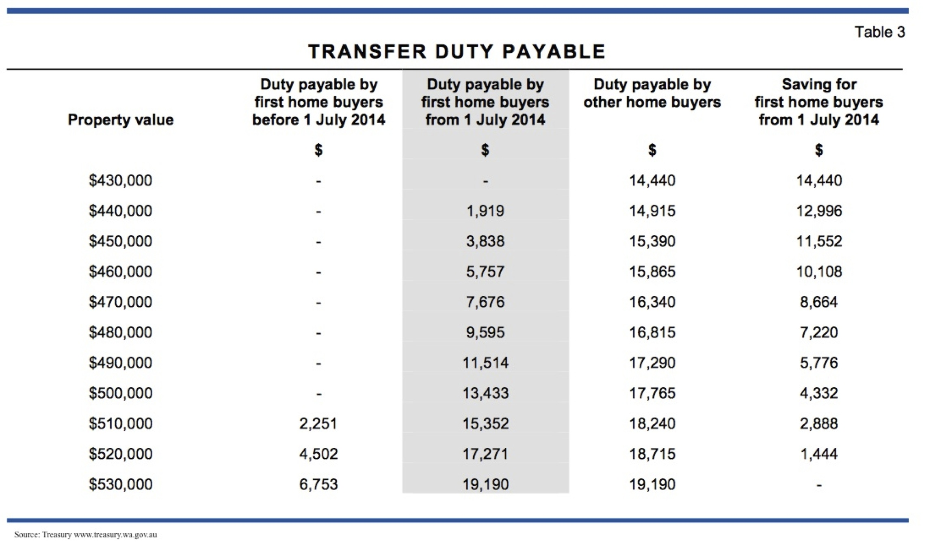

|  |  |
| --- | --- |
| **a)** | How much stamp duty is payable on a property valued at $520 000 if you are a first home buyer and you bought the property after 1 July 2014? |
|  | $17271 ✓ |
| **b)** | What is the percentage savings on stamp duty payable if you bought a property for $450 000 after 1 July 2014 and you are a First home buyer? |
|  | $11552 ÷ 15390 × 100 = 75.06% ✓ |
| **c)** | You bought a property for $520 000 and had $25 000 in savings. How much money would you have to borrow from the bank given you are not a first home buyer? |
|  | Duty payable on $520 000 is $18 715  520 000 + 18715 – 25000 ✓  = $513 715 borrowed from the bank ✓ |
| **d)** | You were offered a deal to borrow this money using a simple interest payment plan. The simple interest rate was 11% and the loan was for a 20 year period. If you pay equal monthly instalments over this 20 year period, including the interest, how much is each payment? |
|  | Total payment on loan = 513715 + 513715 × 11 × 20 ÷ 100 = $1 643 888 ✓  Payments = 1643888 ÷ (12 × 20) = $6849.53 per month (2 d.p.) ✓ |

**~ END OF TEST SECTION 2 ~**